### PHYSICS TEST TWO

Name: ___________________ Mark: /45 Percentage: %

**SECTION A: MULTIPLE CHOICE (15 marks)**

**Please circle your answer on the multiple choice answer grid below.**

1. A B C D

2. A B C D

3. A B C D

4. A B C D

5. A B C D

6. A B C D

7. A B C D

8. A B C D

9. A B C D

10. A B C D

11. A B C D

12. A B C D

13. A B C D

14. A B C D

15. A B C D

**1.** Energy is measured using a unit called the:

(a) kilogram.

(b) metre.

(c) second.

(d) joule.

**2.** Heat from the Sun reaches the Earth by:

(a) convection

(b) conduction

(c) radiation

(d) All of the above

**3.** The energy of a moving object is called:

(a) Nuclear energy.

(b) Gravitational potential energy.

(c) Elastic potential energy.

(d) Kinetic energy.

**4.** A wool jumper keeps a person warm in winter because:

(a) Wool is an insulator (poor conductor).

(b) Wool is a good conductor.

(c) Wool produces heat when you wear it.

(d) All of the above

**5.** The correct definition for energy is:

(a) the ability to do work.

(b) studied in the subject called biology.

(c) How much matter is in an object.

(d) a push or a pull.

**6.** Select which device transforms chemical energy into light energy.

(a) A torch.

(b) A battery operated car.

(c) A kettle.

(d) An electric knife.

**[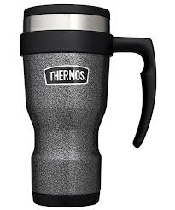](http://www.google.com.au/imgres?hl=en&biw=1920&bih=931&tbm=isch&tbnid=rELzCzmWGMl_FM:&imgrefurl=http://www.outdoorandcountry.co.uk/Thermos-Flask-e28093-Stainless-King-Travel-Mug-Hammertone-450ml.html&docid=jT__EPlCarbg2M&imgurl=http://www.outdoorandcountry.co.uk/userimages/productstyles/product_large/0078490000000.jpg&w=1000&h=1200&ei=2b5CUf_sMdDYkQW5kYDIDA&zoom=1&sa=X&ved=0CMICEIQcMEk&ved=1t:3588,r:73,s:0,i:322&iact=rc&dur=1501&page=2&tbnh=178&tbnw=142&start=40&ndsp=50&tx=76&ty=124)7.** An effective insulator traps heat energy. The effectiveness of three brands of thermos mugs are shown below. An equal volume of water at 80°C was poured into each thermos. The temperature of the water was tested every 10 minutes. These temperatures in each thermos are shown in the table below.

|  |  |  |  |  |
| --- | --- | --- | --- | --- |
| Time (mins) | Silvertop thermos | Geyser thermos | Thermocool thermos | Radiant thermos |
| 0 | 80 | 80 | 80 | 80 |
| 10 | 72 | 80 | 68 | 79 |
| 20 | 65 | 77 | 55 | 78 |
| 30 | 57 | 76 | 48 | 77 |
| 40 | 54 | 76 | 41 | 76 |
| 50 | 52 | 75 | 36 | 73 |
| 60 | 49 | 75 | 34 | 66 |

The most effective insulator is the:

(a) Silvertop thermos.

(b) Geyser thermos.

(c) Thermocool thermos.

(d) Radiant thermos.

**8.** Select the most correct definition for the term ‘energy efficiency’.

(a) A measure of how much input energy is converted to useful output energy.

(b) A measure of how much output energy is converted to useful input energy.

(c) A measure of how much energy is used during an energy transfer.

(d) A measure of how much energy is wasted during an energy transformation.

**9.** Which of the following is the energy flow diagram for a pot of water being heated on an electric hot plate?

(a) Electrical energy 🡪 heat energy

(b) chemical energy🡪 heat energy

(c) heat energy🡪 electric energy

(d) elastic potential energy 🡪 heat energy

**10**. A lid on a paper cup of coffee stops heat loss from:

(a) conduction

(b) convection

(c) radiation

(d) elastic potential energy

**11**. Reflective window tinting on the windows of a car reduces the amount of heat entering the car by reducing the amount of heat transfer by:

(a) conduction

(b) convection

(c) radiation

(d) conduction and convection.

12. A boy is about to jump off of a tree into a river. He has:

(a) potential energy

(b) electric energy

(c) radiation

(d) light energy

13. As a boy falls from a tree into a river he has

(a) potential energy

(b) electric energy

(c) kinetic energy

(d) light energy

14. A girl is about to shoot an arrow from her bow. Before she lets go of the arrow what type of energy does the bow and arrow have?

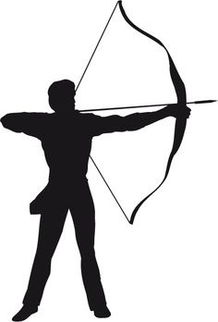

(a) potential elastic energy

(b) electric energy

(c) nuclear energy

(d) light energy

15. Which of the following contains the most energy?

(a) 10,000 j

(b) 10kj

(c) 0.55kj

(d) 11kj

**SECTION B: Short Answer**

**21.** Draw a line between the word and the correct meaning.

|  |  |  |
| --- | --- | --- |
| Words |  | Meaning |
| Heat Conduction |  | Where warm air rises |
| Kinetic energy |  | The information collected during an experiment |
| Convection |  | When energy moves from one place to another |
| Radiation |  | When energy travels as rays |
| Potential energy |  | A material that is a poor conductor of energy |
| Insulator |  | When energy changes from one type of energy to another type of energy |
| Energy transformation |  | When heat is transferred between objects in contact |
| Energy transfer |  | Stored energy |
| Data |  | Energy an moving object has |

(9 marks)

22. There are 1000 joules in a Kilojoule.

1000j=1 Kj

Use this to fill in the table below. You can use a calculator if you want.

|  |  |
| --- | --- |
| Joules | Kilojoules |
| 2,000 |  |
|  | 5 |
| 1,500 |  |
|  | 0.5 |
| 750 |  |

(5 marks)

**23.** Students painted two tin cans different colours. One was painted blue and the other yellow. Each was filled with 50 mL of hot water at 80°C and the temperatures were recorded every minute for eight minutes. The results are presented in the table below.

|  |  |  |
| --- | --- | --- |
| Time (mins) | Temperature (°C) | |
| Blue can | Yellow can |
| 0 | 80 | 80 |
| 1 | 75 | 70 |
| 2 | 70 | 65 |
| 3 | 65 | 60 |
| 4 | 60 | 55 |
| 5 | 55 | 50 |
| 6 | 50 | 45 |
| 7 | 50 | 40 |
| 8 | 45 | 30 |

1. Draw a graph to show this information.

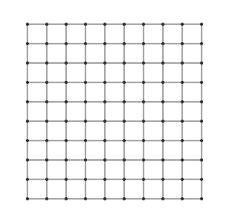

(5 marks)

1. From the graph you drew state which coloured can lost heat the fastest?

**______________________________________________________________________**

(1 marks)

1. Look diagram below and use it to answer the questions that follow.

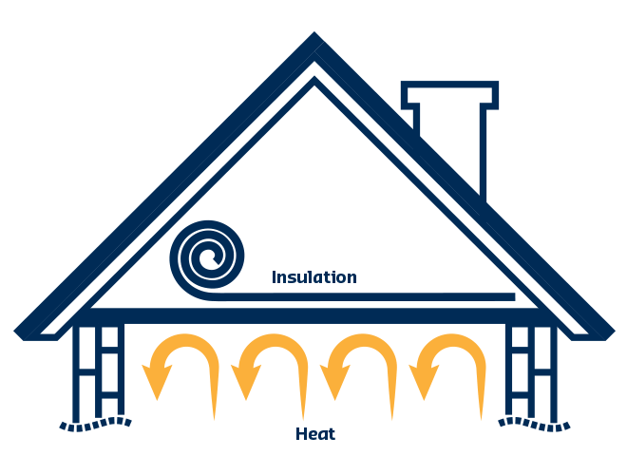

1. The _________________ in the roof cavity stops heat leaving the house by _____________ and _____________. This makes the house more energy _____________________. This will help save the home owner _______________.
2. State two other ways the home owner could make their house more energy efficient?

____________________________________________________________________________________________________________________________________________________________________________________________________________________

(7 marks)

24. Complete the energy flow diagram below to show the changes in types of energy seen in a hand held torch.

C___________potential energy 🡪 ________ energy🡪 _________ energy

(3 marks)